Ideation Phase
Brainstorm & Idea Prioritization Template

Date | 8/10/2026
Team ID | 9100Byte
Project Name | Implement Client Script & UI Policy (Incident)
Maximum Marks | 4 Marks

Brainstorm & Idea Prioritization Template:
Brainstorming provides a free and open environment that encourages everyone within a team to participate in the creative thinking process that leads to problem solving. Prioritizing volume over value, out-of-the-box ideas are welcome and built upon, and all participants are encouraged to collaborate, helping each other develop a rich amount of creative solutions.
Use this template in your own brainstorming sessions so your team can unleash their imagination and start shaping concepts even if you're not sitting in the same room.
Reference: https://www.mural.co/templates/brainstorm-and-idea-prioritization
Prioritization: High priority – conditional mandatory field and save-time validation; Medium priority – automatic Urgency and read-only behavior; Supporting control – list-edit restriction.
Idea 5: Use an onCellEdit Client Script to prevent direct State changes from the Incident list view.
Idea 4: Use an onSubmit Client Script to prevent saving a High impact Incident when Assigned To is empty.
Idea 3: Use an onChange Client Script to automatically set Urgency to High when Impact is High.
Idea 2: Use a UI Policy Action to make Urgency read-only when Impact is High.
Idea 1: Use an Impact-based UI Policy to make Assignment group mandatory for High impact Incidents.
Project Problem Focus: Improve Incident form consistency and reduce incomplete or unsuitable Incident updates.
Step-1: Team Gathering, Collaboration and Select the Problem Statement
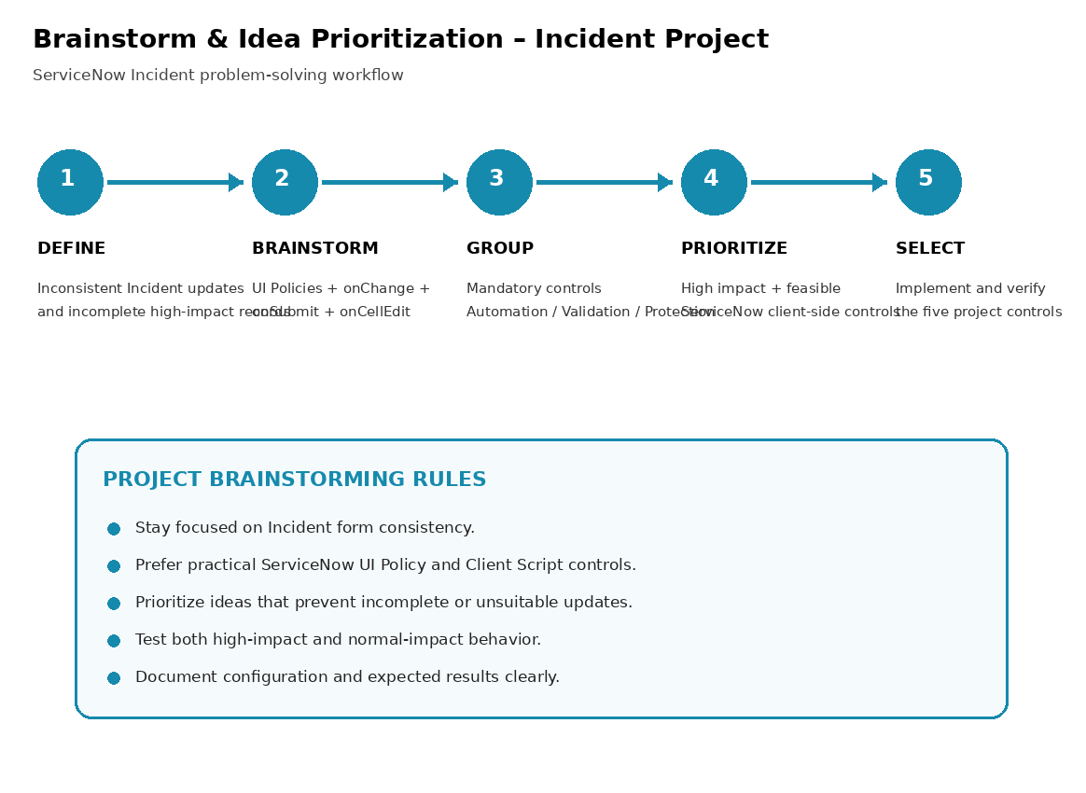

Step-2: Brainstorm, Idea Listing and Grouping
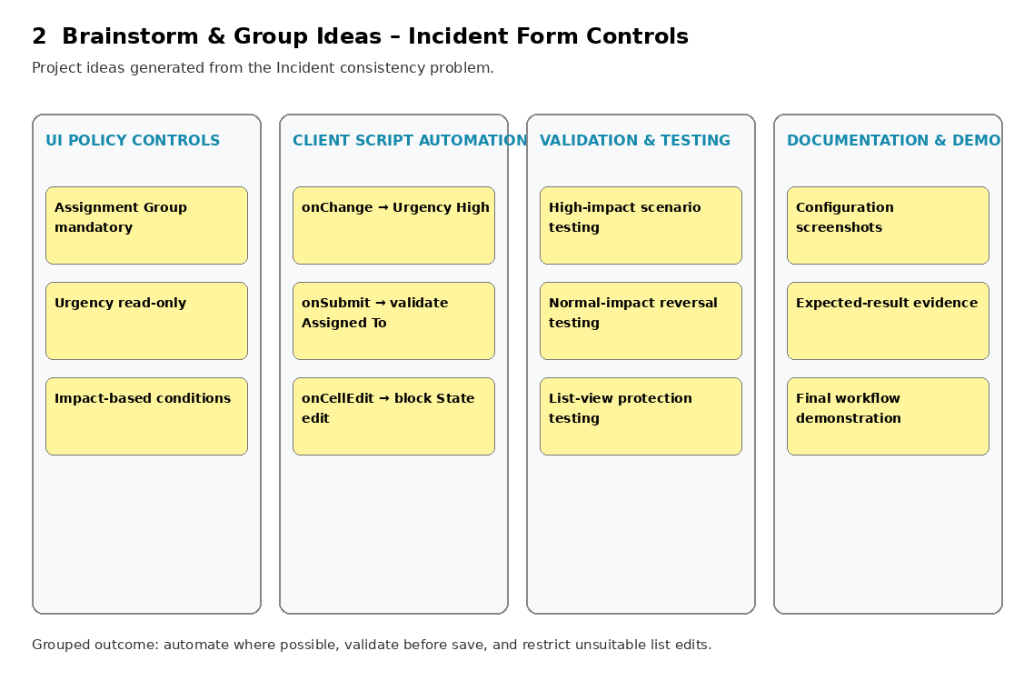

Step-3: Idea Prioritization
